IDEATION PHASE

Brainstorm & Idea Prioritization

|  |  |
| --- | --- |
|  |  |
| Project Name | Inventory Management System for Retailers. |
| Team ID | PNT2022TMID50737 |
|  |  |

Step-1: Team Gathering, Collaboration and Select the Problem Statement

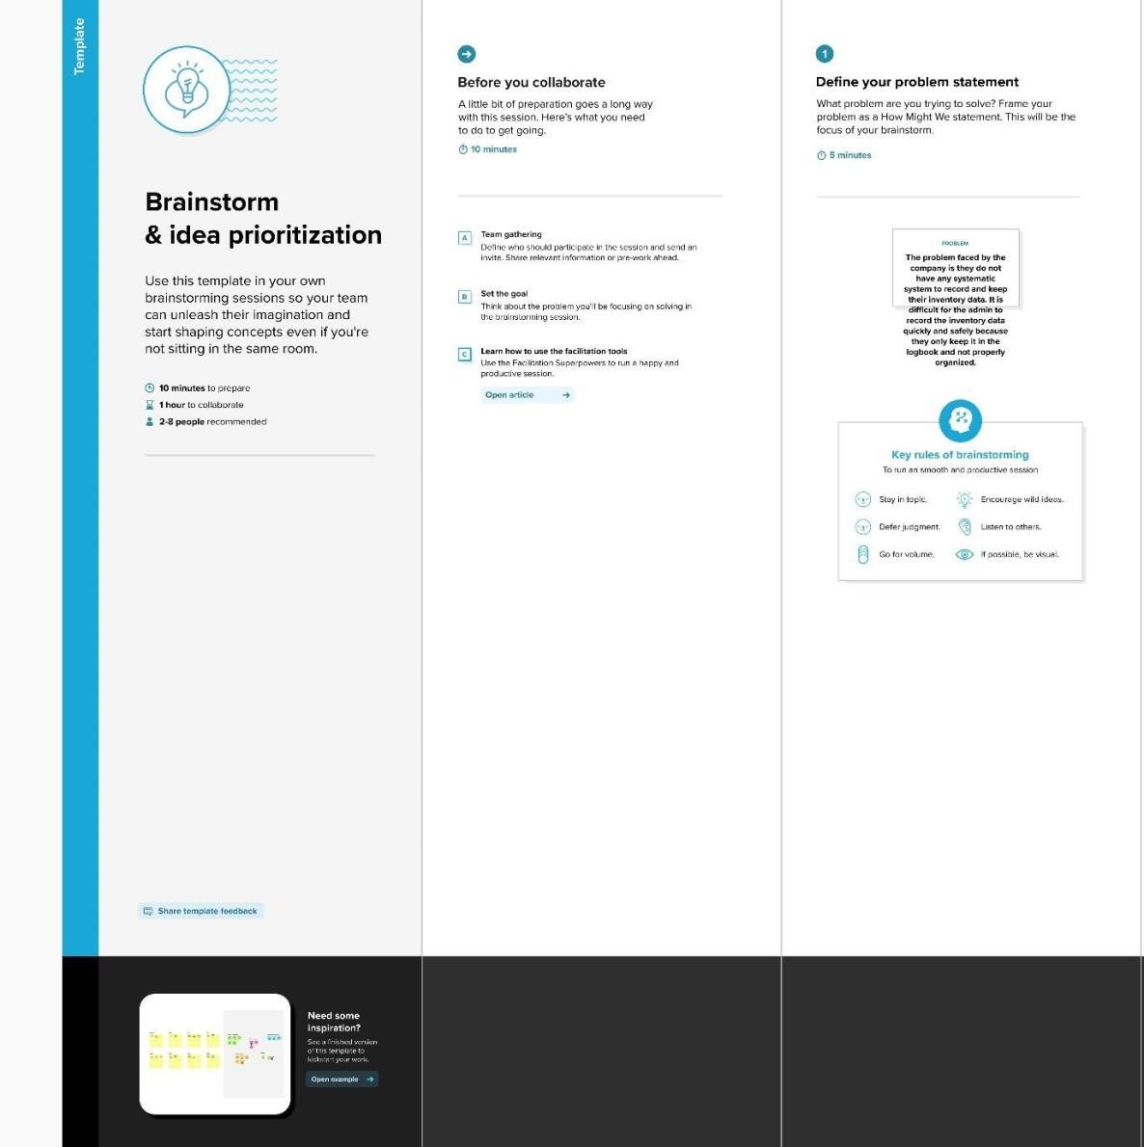

Step-2: Brainstorm, Idea Listening and Grouping

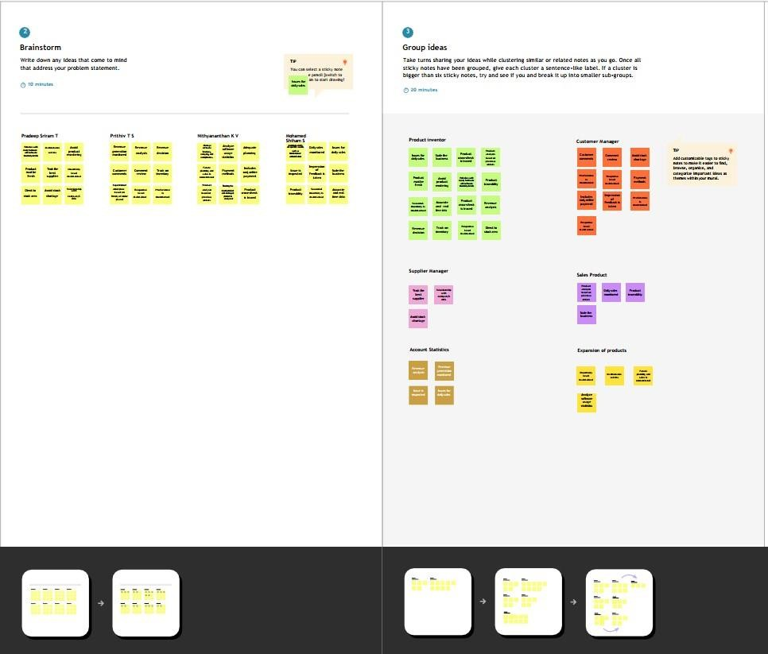

Step-3: Idea Prioritization

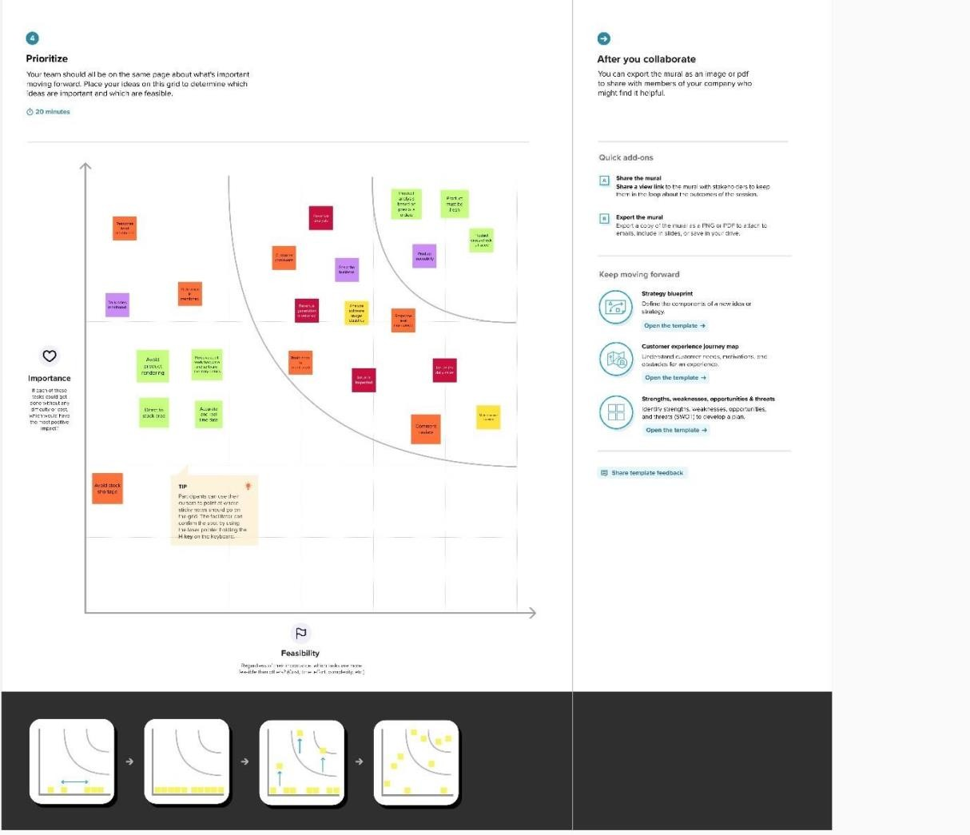

Entire Pitch:

